# Climate Change

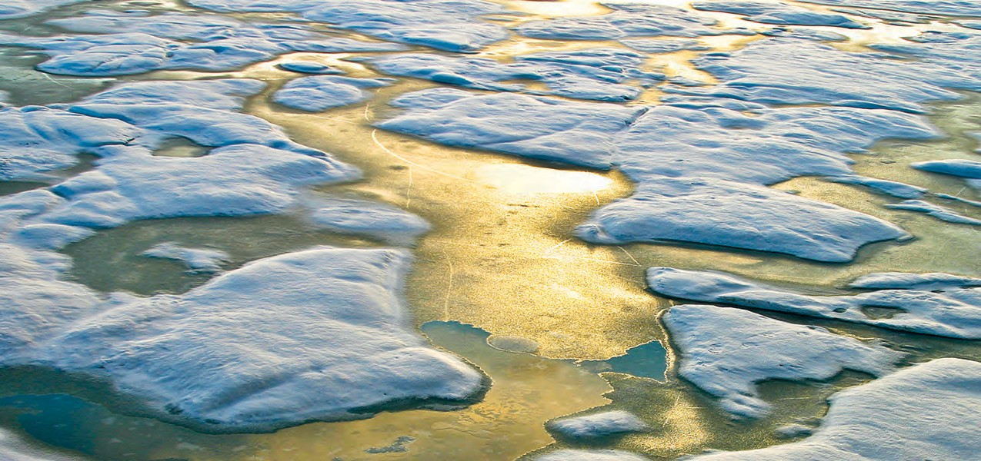Evidence & Causes

# Update 2020

*An overview from the Royal Society and the US National Academy of Sciences*



Foreword

**CLIMATE CHANGE IS ONE OF THE DEFINING ISSUES OF OUR TIME.** It is now more certain

###### than ever, based on many lines of evidence, that humans are changing Earth’s climate. The atmosphere and oceans have warmed, which has been accompanied by sea level rise, a strong decline in Arctic sea ice, and other climate-related changes. The impacts of climate change on people and nature are increasingly apparent. Unprecedented flooding, heat waves, and wildfires have cost billions in damages. Habitats are undergoing rapid shifts in response to changing temperatures and precipitation patterns.

The Royal Society and the US National Academy of Sciences, with their similar missions to promote the use of science to benefit society and to inform critical policy debates, produced the original *Climate Change: Evidence and Causes* in 2014. It was written and reviewed by a UK-US team of leading climate scientists. This new edition, prepared by the same author team, has been updated with the most recent climate data and scientific analyses, all of which reinforce our understanding of human-caused climate change.

###### The evidence is clear. However, due to the nature of science, not every detail is ever totally settled or certain. Nor has every pertinent question yet been answered. Scientific evidence continues to be gathered around the world. Some things have become clearer and new insights have emerged. For example, the period of slower warming during the 2000s and early 2010s has ended with a dramatic jump to warmer temperatures between 2014 and 2015. Antarctic sea ice extent, which had been increasing, began to decline in 2014, reaching a record low in 2017 that has persisted.

These and other recent observations have been woven into the discussions of the questions addressed in this booklet.

###### Calls for action are getting louder. The 2020 Global Risks Perception Survey from the World Economic Forum ranked climate change and related environmental issues as the top five global risks likely to occur within the next ten years. Yet, the international community still has far to go in showing increased ambition on mitigation, adaptation, and other ways to tackle climate change.

Scientific information is a vital component for society to make informed decisions about how to reduce the magnitude of climate change and how to adapt to its impacts. This booklet serves as a key reference document for decision makers, policy makers, educators, and others seeking authoritative answers about the current state of climate-change science.

###### We are grateful that six years ago, under the leadership of Dr. Ralph J. Cicerone, former President of the National Academy of Sciences, and Sir Paul Nurse, former President of the Royal Society, these two organizations partnered to produce a high-level overview of climate change science. As current Presidents of these organizations, we are pleased to offer an update to this key reference, supported by the generosity of the Cicerone Family.

**Marcia McNutt**

*President, National Academy of Sciences*

**Venki Ramakrishnan**

*President, Royal Society*

For further reading

For more detailed discussion of the topics addressed in this document (including references to the underlying original research), see:

* Intergovernmental Panel on Climate Change (IPCC), 2019: *Special Report on the Ocean and Cryosphere in a Changing Climate* [https://[www.ipcc.ch/srocc](http://www.ipcc.ch/srocc)]
* National Academies of Sciences, Engineering, and Medicine (NASEM), 2019: *Negative Emissions Technologies and Reliable Sequestration: A Research Agenda* [https://[www.nap.edu/catalog/25259](http://www.nap.edu/catalog/25259)]
* Royal Society, 2018: *Greenhouse gas removal*

[https://raeng.org.uk/greenhousegasremoval]

* U.S. Global Change Research Program (USGCRP), 2018: *Fourth National Climate Assessment Volume II: Impacts, Risks, and Adaptation in the United States* [https://nca2018.globalchange.gov]
* IPCC, 2018: *Global Warming of 1.5°C* [https://[www.ipcc.ch/sr15]](http://www.ipcc.ch/sr15)
* USGCRP, 2017: *Fourth National Climate Assessment Volume I: Climate Science Special Reports* [https://science2017.globalchange.gov]
* NASEM, 2016: Attribution of Extreme Weather Events in the Context of Climate Change [https://[www.nap.edu/catalog/21852](http://www.nap.edu/catalog/21852)]
* IPCC, 2013: *Fifth Assessment Report (AR5) Working Group 1. Climate Change 2013: The Physical Science Basis* [https:/[/w](http://www.ipcc.ch/report/ar5/wg1)w[w.ipcc.ch/report/ar5/wg1](http://www.ipcc.ch/report/ar5/wg1)]
* NRC, 2013: Abrupt Impacts of Climate Change: Anticipating Surprises [https://[www.nap.edu/catalog/18373](http://www.nap.edu/catalog/18373)]
* NRC, 2011: *Climate Stabilization Targets: Emissions, Concentrations, and Impacts Over Decades to Millennia* [https://[www.nap.edu/catalog/12877](http://www.nap.edu/catalog/12877)]
* Royal Society 2010: *Climate Change: A Summary of the Science* [https://royalsociety.org/topics-policy/publications/2010/ climate-change-summary-science]
* NRC, 2010: *America’s Climate Choices: Advancing the Science of Climate Change* [https:/[/w](http://www.nap.edu/catalog/12782)w[w.nap.edu/catalog/12782](http://www.nap.edu/catalog/12782)]

Much of the original data underlying the scientific findings discussed here are available at:

* https://data.ucar.edu/
* https://climatedataguide.ucar.edu
* https://iridl.ldeo.columbia.edu
* https://ess-dive.lbl.gov/
* https:/[/w](http://www.ncdc.noaa.gov/)w[w.ncdc.noaa.gov/](http://www.ncdc.noaa.gov/)
* https:/[/w](http://www.esrl.noaa.gov/gmd/ccgg/trends/)w[w.esrl.noaa.gov/gmd/ccgg/trends/](http://www.esrl.noaa.gov/gmd/ccgg/trends/)
* [http://scrippsco2.ucsd.edu](http://scrippsco2.ucsd.edu/)
* <http://hahana.soest.hawaii.edu/hot/>



**THE NATIONAL ACADEMY OF SCIENCES (NAS)** was established to advise the United States on scientific and technical issues when President Lincoln signed a Congressional charter in 1863. The National Research Council, the operating arm of the National Academy of Sciences and the National Academy of Engineering, has issued numerous reports on the causes of and potential responses to climate change. Climate change resources from the National Research Council are available at nationalacademies.org/climate.

**THE ROYAL SOCIETY** is a self-governing Fellowship of many of the world’s most distinguished scientists. Its members are drawn from all areas of science, engineering, and medicine. It is the national academy of science in the UK. The Society’s fundamental purpose, reflected in its founding Charters of the 1660s, is to recognise, promote, and support excellence in science, and to encourage the development and use of science

for the benefit of humanity. More information on the Society’s climate change work is available at royalsociety.org/policy/climate-change





contents

**Summary** 2

**Climate Change Q& A**

1. Is the climate warming? 3
2. How do scientists know that recent climate change is largely caused by human activities? 5
3. CO2 is already in the atmosphere naturally, so why are emissions from

human activity significant? 6

1. What role has the Sun played in climate change in recent decades? 7
2. What do changes in the vertical structure of atmospheric temperature—from the

surface up to the stratosphere—tell us about the causes of recent climate change? 8

1. Climate is always changing. Why is climate change of concern now? 9
2. Is the current level of atmospheric CO2 concentration unprecedented in Earth’s history? 9
3. Is there a point at which adding more CO2 will not cause further warming? 10
4. Does the rate of warming vary from one decade to another? 11
5. Did the slowdown of warming during the 2000s to early 2010s

mean that climate change is no longer happening? 12

**The Basics of Climate Change B1–B8**

**Climate Change Q& A** *(continued)*

1. If the world is warming, why are some winters and summers still very cold? 13
2. Why is Arctic sea ice decreasing while Antarctic sea ice has changed little? 14
3. How does climate change affect the strength and frequency

of floods, droughts, hurricanes, and tornadoes? 15

1. How fast is sea level rising? 16
2. What is ocean acidification and why does it matter? 17
3. How confident are scientists that Earth will warm further over the coming century? 18
4. Are climate changes of a few degrees a cause for concern? 19
5. What are scientists doing to address key uncertainties

in our understanding of the climate system? 19

1. Are disaster scenarios about tipping points like “turning off the Gulf Stream”

and release of methane from the Arctic a cause for concern? 21

1. If emissions of greenhouse gases were stopped, would the climate return

to the conditions of 200 years ago? 22

**Conclusion** 23

**Acknowledgements** 24

Summary

**GREENHOUSE GASES** such as carbon dioxide (CO2) absorb heat (infrared radiation) emitted from Earth’s surface. Increases in the atmospheric concentrations of these gases cause Earth to warm by trapping more of this heat. Human activities—especially the burning of fossil fuels since the start of the Industrial Revolution—have increased

atmospheric CO2 concentrations by more than 40%, with over half the increase occurring since 1970. Since 1900, the global average surface temperature has increased by about

1 °C (1.8 °F). This has been accompanied by warming of the ocean, a rise in sea level, a strong decline in Arctic sea ice, widespread increases in the frequency and intensity

of heatwaves, and many other associated climate effects. Much of this warming has occurred in the last five decades. Detailed analyses have shown that the warming during this period is mainly a result of the increased concentrations of CO2 and other

greenhouse gases. Continued emissions of these gases will cause further climate change, including substantial increases in global average surface temperature and important changes in regional climate. The magnitude and timing of these changes will depend on many factors, and slowdowns and accelerations in warming lasting a decade or more will continue to occur. However, long-term climate change over many decades will depend mainly on the total amount of CO2 and other greenhouse gases emitted as a result of human activities.

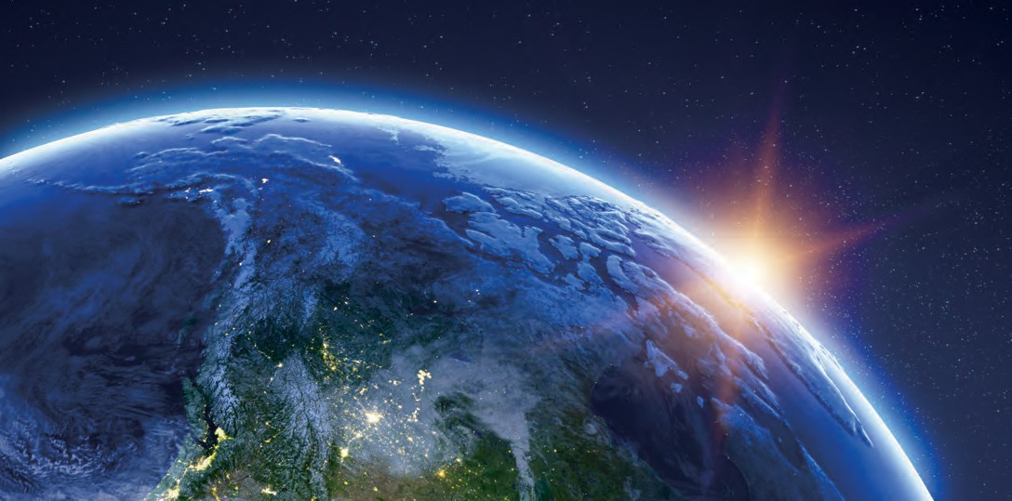

Q& A

Is the climate warming?

1

Yes. Earth’s average surface air temperature has increased by about 1 °C (1.8 °F) since 1900, with over half of the increase occurring since the mid-1970s [Figure 1a]. A wide range of other observations (such as reduced Arctic sea ice extent and increased ocean heat content) and indications from the natural world (such as poleward shifts of temperature-sensitive species of fish, mammals, insects, etc.) together provide incontrovertible evidence of planetary-scale warming.

The clearest evidence for surface warming comes from widespread thermometer records that, in some places, extend back to the late 19th century. Today, temperatures are monitored at many thousands of locations, over both the land and ocean surface. Indirect estimates of temperature change from such sources as tree rings and ice cores help to place recent temperature changes in the context of the past. In terms of the average surface temperature of Earth, these indirect estimates show that 1989 to 2019 was very likely the warmest 30-year period in more than 800 years; the most recent decade, 2010-2019, is the warmest decade in the instrumental record so far (since 1850).

A wide range of other observations provides a more comprehensive picture of warming throughout the climate system. For example, the lower atmosphere and the upper layers of the ocean have also warmed, snow and ice cover are decreasing in the Northern Hemisphere, the Greenland ice sheet is shrinking, and sea level is rising [Figure 1b]. These measurements are made with a variety of land-, ocean-, and space-based monitoring systems, which gives added confidence in the reality of global-scale warming of Earth’s climate.

**Figure 1a.** Earth’s global average surface temperature has risen as shown in this plot of combined land and ocean measurements from 1850 to 2019, derived from three independent analyses of the

available data sets. The temperature changes are relative to the global average surface temperature of 1961−1990. *Source: NOAA Climate. gov; data from UK Met Office Hadley Centre (maroon), US National Aeronautics and Space Administration Goddard Institute for Space Studies*

**Annual global surface temperature** (1850−2019)

1.0

NASA (GISS) NOAA (NCEI)

**1961−1990 average**

**Difference from average temperature** (°C)

0.8

0.6

0.4

0.2

0

-0.2

-0.4

-0.6

-0.8

Hadley Centre (UK Met)

*(red), and US National Oceanic*

*and Atmospheric Administration National Centers for Environmental Information (orange).*

1850 1870 1890 1910 1930 1950 1970 1990 2010

**Year**

**Figure 1b.** A large amount of observational evidence besides surface temperature records shows that Earth’s climate is changing.

For example, additional evidence of a warming trend can be found in the dramatic decrease in the extent of Arctic sea ice at its summer minimum (which occurs in September), the decrease in June snow cover in the Northern Hemisphere, the increases in the

**Arctic sea ice extent in winter and summer** (1979−2019)

20

**1981−2010**

**average**

**September minimum**

**March maximum**

**Difference from average** (percent)

0

-20

-40

1955 1965 1975 1985 1995 2005 2015

global average upper ocean (upper 700 m or 2300 feet) heat content (shown relative to the 1955–2006 average), and the rise in global sea level. *Source: NOAA Climate.gov*

**Year**

**Northern Hemisphere June snow cover** (1967−2019)

6

**1967−2019**

**average**

no data

**Difference from average** (millions of km2)

4

2

Data: NSIDC

0

-2

-4

-6

1955

1965 1975 1985 1995 2005 2015

**Upper ocean heat content** (1955−2019)

20

**1955−2006**

**average**

**Year**

Data: Rutgers Snow Lab

15

**Difference from average** (1022 Joules)

10

5

0

-5

-10

1955 1965 1975 1985 1995 2005 2015

**Global sea level** (1955-2019)

80

**1993−2008**

**average**

**Difference from average** (millimeters)

60

40

20

0

-20

-40

-60

-80

-100

**Year**

Data: NOAA NODC

1955 1965 1975 1985 1995 2005 2015

**Year** Data: Church & White 2011, UHSLC

How do scientists know that recent climate change is largely caused by human activities?

Scientists know that recent climate change is largely caused by human activities from an understanding of basic physics, comparing observations with models, and fingerprinting the detailed patterns of climate change caused by different human and natural influences.

2

Since the mid-1800s, scientists have known that CO2 is one of the main greenhouse gases of importance to Earth’s energy balance. Direct measurements of CO2 in the atmosphere and in air trapped in ice show that atmospheric CO2 increased by more than 40% from 1800 to 2019. Measurements of different forms of carbon (isotopes, see Question 3) reveal that this increase is due to human activities. Other greenhouse gases (notably methane and nitrous oxide) are also increasing as a consequence of human activities. The observed global surface temperature rise since 1900 is consistent with detailed calculations of the impacts of the observed increase in atmospheric greenhouse gases (and other human-induced changes) on Earth’s energy balance.

Different influences on climate have different signatures in climate records. These unique fingerprints are easier to see by probing beyond a single number (such as the average temperature of Earth’s surface), and by looking instead at the geographical and seasonal patterns of climate change. The observed patterns of surface warming, temperature changes through the atmosphere, increases in ocean heat content, increases in atmospheric moisture, sea level rise, and increased melting of land and sea ice also match the patterns scientists expect to see due to human activities (see Question 5).

The expected changes in climate are based on our understanding of how greenhouse gases trap heat. Both this fundamental understanding of the physics of greenhouse gases and pattern-based fingerprint studies show that natural causes alone are inadequate to explain the recent observed changes in climate. Natural causes include variations in the Sun’s output and in Earth’s orbit around the Sun, volcanic eruptions, and internal fluctuations in the climate system (such as El Niño and La Niña). Calculations using climate models (see infobox, p. 20) have been used to simulate what would have happened to global temperatures if only natural factors were influencing the climate system. These simulations yield little surface warming, or even a slight cooling, over the 20th century and into the 21st. Only when models include human influences on the composition of the atmosphere are the resulting temperature changes consistent with observed changes.

## CO2 is already in the atmosphere naturally, so why are emissions from human activity significant?

Human activities have significantly disturbed the natural carbon cycle by extracting long- buried fossil fuels and burning them for energy, thus releasing CO2 to the atmosphere.

3

In nature, CO2 is exchanged continually between the atmosphere, plants, and animals through photosynthesis, respiration, and decomposition, and between the atmosphere and ocean through gas exchange. A very small amount of CO2 (roughly 1% of the emission rate from fossil fuel combustion) is also emitted in volcanic eruptions. This is balanced by an equivalent amount that is removed by chemical weathering of rocks.

The CO2 level in 2019 was more than 40% higher than it was in the 19th century. Most of this CO2 increase has taken place since 1970, about the time when global energy consumption accelerated. Measured decreases in the fraction of other forms of carbon (the isotopes 14C and 13C) and a small decrease in atmospheric oxygen concentration (observations of which have been available since 1990) show that

the rise in CO2 is largely from combustion of fossil fuels (which have low 13C fractions and no 14C). Deforestation and other land use changes have also released carbon from the biosphere (living world) where it normally resides for decades to centuries. The additional CO2 from fossil fuel burning and deforestation has disturbed the balance of the carbon cycle, because the natural processes that could restore the balance are too slow compared to the rates at which human activities are adding CO2 to the atmosphere. As a result, a substantial fraction of the CO2 emitted from human activities accumulates in the atmosphere, where some of it will remain not just for decades or centuries, but for thousands of

years. Comparison with the CO2 levels measured in air extracted from ice cores indicates that the current concentrations are substantially higher than they have been in at least 800,000 years (see Question 6).

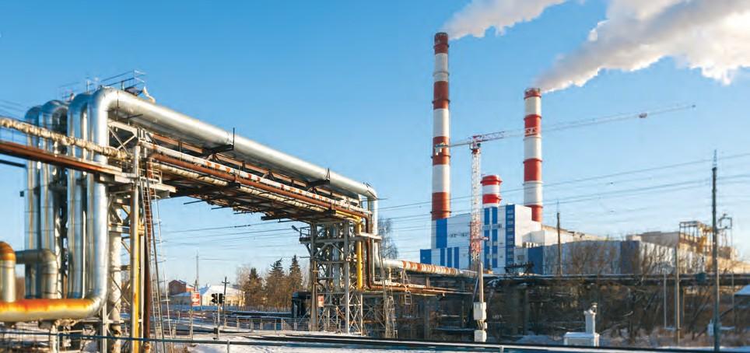

4

What role has the Sun played in climate change in recent decades?

The Sun provides the primary source of energy driving Earth’s climate system, but its variations have played very little role in the climate changes observed in recent decades. Direct satellite measurements since the late 1970s show no net increase in the Sun’s out- put, while at the same time global surface temperatures have increased **[** FIGURE **2].**

For periods before the onset of satellite measurements, knowledge about solar changes is less certain because the changes are inferred from indirect sources — including the number of sunspots and the abundance of certain forms (isotopes) of carbon or beryllium atoms, whose production rates in Earth’s atmosphere are influenced by variations in the Sun. There is evidence that the 11-year solar cycle, during which the Sun’s energy output varies by roughly 0.1%, can influence ozone concentrations, temperatures, and winds in the stratosphere (the layer in the atmosphere above the troposphere, typically from 12 to 50km above earth’s surface, depending on latitude and season). These stratospheric changes may have

a small effect on surface climate over the 11-year cycle. However, the available evidence does not indicate pronounced long-term changes in the Sun’s output over the past century, during which time human- induced increases in CO2 concentrations have been the dominant influence on the long-term global surface temperature increase. Further evidence that current warming is not a result of solar changes can be found in the temperature trends at different altitudes in the atmosphere (see Question 5).

FIGURE 2**.** Measurements of the Sun’s energy incident on Earth show no net increase in solar forcing during the past 40 years, and therefore this cannot be responsible for warming during that period. The data show only small periodic amplitude variations associated with the Sun’s 11-year cycle. *Source: TSI data from Physikalisch-Meteorologisches Observatorium Davos, Switzerland,*

*on the new VIRGO scale from 1978 to mid-2018; temperature data for same time period from the HadCRUT4 dataset, UK Met Office, Hadley Centre.*

**1.2**

**1.0**

**Difference from average temperature (°C)**

|  |  |  |  |  |  |  |  |  |
| --- | --- | --- | --- | --- | --- | --- | --- | --- |
| **Glo** | **bal averag** | **e surface** | **temperatur** | **e** |  |  |  |  |
|  |  |  |  |  |  |  |  |  |
|  |  |  |  |  |  |  |  |  |
|  |  |  |  |  |  |  |  |  |

**0.8**

**0.6**

**0.4**

**0.2**

**0.0**

**-0.2**

**-0.4**

|  |  |  |  |  |  |  |  |
| --- | --- | --- | --- | --- | --- | --- | --- |
| **1980** | **1985** | **1990** | **1995** | **2000** | **2005** | **2010** | **2015** |
|  |  |  |  |  |  |  |  |
|  |  |  |  |  |  |  |  |
|  |  |  |  |  |  |  |  |
|  |  |  |  |  |  |  |  |
|  |  |  |  |  |  |  |  |
|  |  |  |  |  |  |  |  |
| **1980** | **1985** | **1990** | **1995** | **2000** | **2005** | **2010** | **2015** |

**1362.5**

|  |  |  |  |  |  |  |  |  |
| --- | --- | --- | --- | --- | --- | --- | --- | --- |
| **Me** | **asuremen** | **t of the sun** | **’s energy** |  |  |  |  |  |
|  |  |  |  |  |  |  |  |  |
|  |  |  |  |  |  |  |  |  |
|  |  |  |  |  |  |  |  |  |
|  |  |  |  |  |  |  |  |  |
|  |  |  |  |  |  |  |  |  |

**1362.0**

**Total solar irradiance (W m–2)**

**1361.5**

**1361.0**

**1360.5**

**1360.0**

**1359.5**

## What do changes in the vertical structure of atmospheric temperature

5

—from the surface up to the stratosphere—tell us about the

## causes of recent climate change?

The observed warming in the lower atmosphere and cooling in the upper atmosphere provide us with key insights into the underlying causes of climate change and reveal that natural factors alone cannot explain the observed changes.

In the early 1960s, results from mathematical/physical models of the climate system first showed that human-induced increases in CO2 would be expected to lead to gradual warming of the lower atmosphere (the troposphere) and cooling of higher levels of the atmosphere (the stratosphere). In contrast, increases in the Sun’s output would warm both the troposphere and the full vertical extent of the stratosphere. At that time, there was insufficient observational data to test this prediction, but temperature measurements from weather balloons and satellites have since confirmed these early forecasts. It is now known that the observed pattern of tropospheric warming and stratospheric cooling over the past 40 years is broadly consistent with computer model simulations that include increases in CO2 and decreases in stratospheric ozone, each caused by human activities. The observed pattern is not consistent with purely natural changes in the Sun’s energy output, volcanic activity, or natural climate variations such as El Niño and La Niña.

Despite this agreement between the global-scale patterns of modelled and observed atmospheric temperature change, there are still some differences. The most noticeable differences are in the tropics, where models currently show more warming in the troposphere than has been observed, and in the Arctic, where the observed warming of the troposphere is greater than in most models.

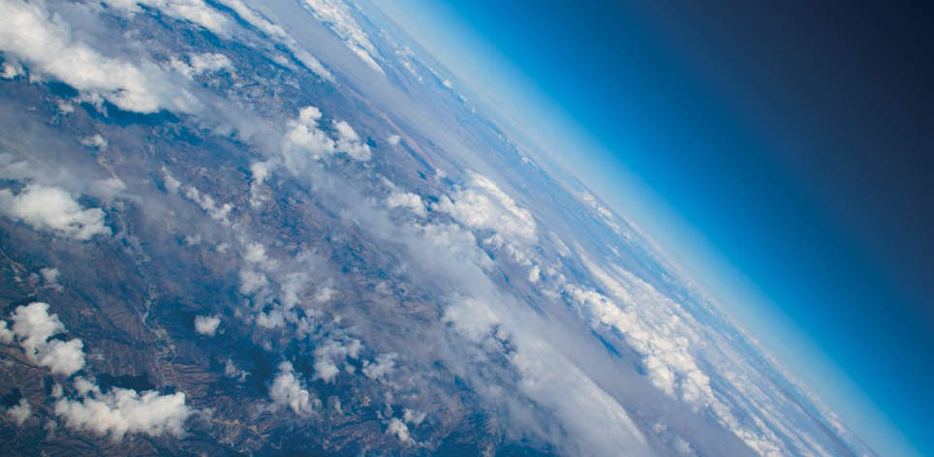

## Climate is always changing. Why is climate change of concern now?

All major climate changes, including natural ones, are disruptive. Past climate changes led to extinction of many species, population migrations, and pronounced changes in the land surface and ocean circulation. The speed of the current climate change is faster than most of the past events, making it more difficult for human societies and the natural world to adapt.

6

The largest global-scale climate variations in Earth’s recent geological past are the ice age cycles (see infobox, p.B4), which are cold glacial periods followed by shorter warm periods **[ Figure 3].** The last few of these natural cycles have recurred roughly every 100,000 years. They are mainly paced by slow changes in Earth’s orbit, which alter the way the Sun’s energy is distributed with latitude and by season on Earth. These orbital changes are very small over the last several hundred years, and alone are not sufficient to cause the observed magnitude of change in temperature since the Industrial Revolution, nor to act on the whole Earth. On

ice-age timescales, these gradual orbital variations have led to changes in the extent of ice sheets and in the abundance of CO2 and other greenhouse gases, which in turn have amplified the initial temperature change.

Recent estimates of the increase in global average temperature since the end of the last ice age are 4 to 5 °C (7 to 9 °F). That change occurred over a period of about 7,000 years, starting 18,000 years ago. CO2

has risen more than 40% in just the past 200 years, much of this since the 1970s, contributing to human alteration of the planet’s energy budget that has so far warmed Earth by about 1 °C (1.8 °F). If the rise in CO2 continues unchecked, warming of the same magnitude as the increase out of the ice age can be expected by the end of this century or soon after. This speed of warming is more than ten times that at the end of an ice age, the fastest known natural sustained change on a global scale.

## Is the current level of atmospheric CO2 concentration unprecedented in Earth’s history?

The present level of atmospheric CO2 concentration is almost certainly unprecedented in the past million years, during which time modern humans evolved and societies developed. The atmospheric CO2 concentration was however higher in Earth’s more distant past (many millions of years ago), at which time palaeoclimatic and geological data indicate that temperatures and sea levels were also higher than they are today.

7

Measurements of air in ice cores show that for the past 800,000 years up until the 20th century, the atmospheric CO2 concentration stayed within the range 170 to 300 parts per million (ppm), making the recent rapid rise to more than 400 ppm over 200 years particularly remarkable **[figure 3]**. During the glacial cycles

of the past 800,000 years both CO2 and methane have acted as important amplifiers of the climate changes triggered by variations in Earth’s orbit around the Sun. As Earth warmed from the last ice age, temperature

*continued*

FIGYRE 3**.** Data from ice cores have been used to reconstruct Antarctic temperatures and atmospheric CO2 concentrations over the past 800,000 years. Temperature is based on measurements of the isotopic content of water in the

Dome C ice core. CO2 is measured in air trapped in ice, and is a composite of the Dome C and Vostok ice core.

The current CO2 concentration (blue dot) is from atmospheric measurements. The cyclical pattern of temperature variations constitutes the ice age/ interglacial

cycles. During these cycles, changes in CO2 concentrations (in blue) track closely with changes in temperature (in orange). As the record shows, the recent increase in atmospheric CO2 concentration is unprecedented in the past 800,000 years.

Atmospheric CO2 concentration surpassed 400 ppm in 2016, and the average concentration in 2019 was more than 411 ppm. *Source: Based*

*on figure by Jeremy Shakun, data from Lüthi et al., 2008 and Jouzel et al., 2007.*

and CO2 started to rise at approximately the same time and continued to rise in tandem from about 18,000 to 11,000 years ago. Changes in ocean temperature, circulation, chemistry, and biology caused CO2 to be released to the atmosphere, which combined with other feedbacks to push Earth into an even warmer state.

For earlier geological times, CO2 concentrations and temperatures have been inferred from less direct methods. Those suggest that the concentration of CO2 last approached 400 ppm about 3 to 5 million years ago, a period when global average surface temperature is estimated to have been about 2 to 3.5°C higher than in the pre-industrial period. At 50 million years ago, CO2 may have reached 1000 ppm, and global average temperature was probably about 10°C warmer than today. Under those conditions, Earth had little ice, and sea level was at least 60 metres higher than current levels.

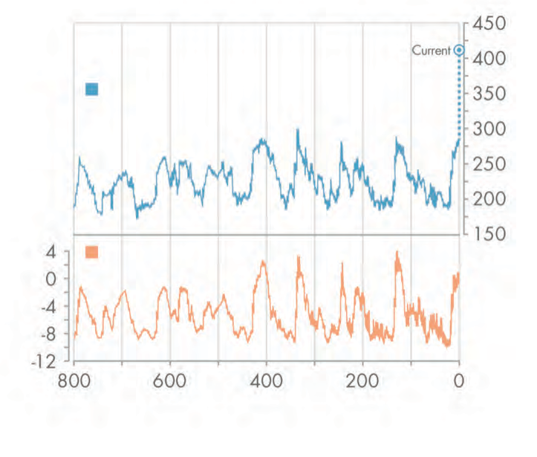

450

400

350

300

250

200

150

4

0

-4

-8

-12

Atmospheric CO2 concentration

CO2 (ppm)

Antarctic temperature

Temperature change (°C)

## Is there a point at which adding more CO2 will not cause further warming?

No. Adding more CO2 to the atmosphere will cause surface temperatures to continue to increase. As the atmospheric concentrations of CO2 increase, the addition of extra CO2 becomes progressively less effective at trapping Earth’s energy, but surface temperature will still rise.

8

0

200

400

Years ago (in thousands)

600

800

Our understanding of the physics by which CO2 affects Earth’s energy balance is confirmed by laboratory measurements, as well as by detailed satellite and surface observations of the emission and absorption of infrared energy by the atmosphere. Greenhouse gases absorb some of the infrared energy that Earth emits in so-called bands of stronger absorption that occur at certain wavelengths. Different gases absorb energy at different wavelengths. CO2 has its strongest heat-trapping band centred at a wavelength of 15 micrometres (millionths of a metre), with absorption that spreads out a few micrometres on either side. There are also many weaker absorption bands. As CO2 concentrations increase, the absorption at the cen- tre of the strong band is already so intense that it plays little role in causing additional warming. However, more energy is absorbed in the weaker bands and away from the centre of the strong band, causing the surface and lower atmosphere to warm further.

9

Does the rate of warming vary from one decade to another?

Yes. The observed warming rate has varied from year to year, decade to decade, and place to place, as is expected from our understanding of the climate system. These shorter- term variations are mostly due to natural causes, and do not contradict our fundamental understanding that the long-term warming trend is primarily due to human-induced changes in the atmospheric levels of CO2 and other greenhouse gases.

**Figure 4.** The climate system varies naturally from year to year and from decade to decade. To make reliable inferences about human-induced climate change, multi-decadal and longer records are typically used.

Calculating a “running average” over these longer timescales allows one to more easily see long-term trends. For the global average temperature for the period 1850-2019 (using the data from the UK Met Office Hadley Centre relative to the 1961-90

Even as CO2 is rising steadily in the atmosphere, leading to gradual warming of Earth’s surface, many natural factors are modulating this long-term warming. Large volcanic eruptions increase the number of small particles in the stratosphere. These particles reflect sunlight, leading to short-term surface cooling lasting typically two to three years, followed by a slow recovery. Ocean circulation and mixing vary naturally on many time scales, causing variations in sea surface temperatures as well as changes in the rate at which heat is transported to greater depths. For example, the tropical Pacific swings between warm El Niño and cooler La Niña events on timescales of two to seven years. Scientists study many different types of climate variations, such as those on decadal and multi-decadal timescales in the Pacific and North Atlantic Oceans. Each

type of variation has its own unique characteristics. These oceanic variations are associated with significant regional and global shifts in temperature and rainfall patterns that are evident in the observations.

Warming from decade to decade can also be affected by human factors such as variations in emissions of greenhouse gases and aerosols (airborne particles that can have both warming and cooling effects) from coal-fired power plants and other pollution sources.

These variations in the temperature trend are clearly evident in the observed temperature record

**[** Figure 4 **].** Short-term natural climate variations could also affect the long-term human-induced climate change signal and vice-versa, because climate variations on different space and timescales can interact with one another. It is partly for this reason that climate change projections are made using climate models (see infobox, p.20) that can account for many different types of climate variations and their interactions. Reliable inferences about human-induced climate change must be made with a longer view, using records that cover many decades.

0.5°C



Annual average

10-year average

30-year average

60-year average

0°C

Difference from average temperature (°C) relative to 1961-1990

Difference from average temperature (°C) relative to 1961-1990

average) the plots show (top) the average and range of uncertainty for annually averaged data; (2nd plot) the annual average temperature

for the ten years centred on any given date; (3rd plot) the equivalent picture for 30-year; and (4th plot) the 60-year averages. *Source: Met Office Hadley Centre, based on the*

*HadCRUT4 dataset from the Met Office and Climatic Research Unit (Morice et al., 2012).*

−0.5°C

0.5°C

0°C

−0.5°C

1850 1900 1950 2000

0.5°C

0°C

−0.5°C

0.5°C

0°C

−0.5°C

## Did the slowdown of warming during the 2000s to early 2010s mean that climate change is no longer happening?

No. After the very warm year 1998 that followed the strong 1997-98 El Niño, the increase in average surface temperature slowed relative to the previous decade of rapid

temperature increases. Despite the slower rate of warming, the 2000s were warmer than the 1990s. The limited period of slower warming ended with a dramatic jump to warmer temperatures between 2014 and 2015, with all the years from 2015-2019 warmer than

any preceding year in the instrumental record. A short-term slowdown in the warming of Earth’s surface does not invalidate our understanding of long-term changes in global temperature arising from human-induced changes in greenhouse gases.

10

Decades of slow warming as well as decades of accelerated warming occur naturally in the climate system. Decades that are cold or warm compared to the long-term trend are seen in the observations of the past 150 years and are also captured by climate models. Because the atmosphere stores very little heat, surface temperatures can be rapidly affected by heat uptake elsewhere in the climate system and by changes in external influences on climate (such as particles formed from material lofted high into the atmosphere from volcanic eruptions).

More than 90% of the heat added to the Earth system in recent decades has been absorbed by the oceans and penetrates only slowly into deep water. A faster rate of heat penetration into the deeper ocean will slow the warming seen at the surface and in the atmosphere, but by itself it will not change the long-term warming that will occur from a given amount of CO2. For example, recent studies show that some heat comes out of the ocean into the atmosphere during warm El Niño events, and more heat penetrates to ocean depths in cold La Niñas. Such changes occur repeatedly over timescales of decades and longer. An example is the major El Niño event in 1997–98 when the globally averaged air temperature soared to the highest level in the 20th century as the ocean lost heat to the atmosphere, mainly by evaporation.

Even during the slowdown in the rise of average surface temperature, a longer-term warming trend was still evident (see Figure 4). Over that period, for example, record heatwaves were documented in

Europe (summer 2003), in Russia (summer 2010), in the USA (July 2012), and in Australia (January 2013). Each of the last four decades was warmer than any previous decade since widespread thermometer measurements were introduced in the 1850s. The continuing effects of the warming climate are seen in the increasing trends in ocean heat content and sea level, as well as in the continued melting of Arctic sea ice, glaciers and the Greenland ice sheet.

The Basics of

Climate Change

### Greenhouse gases affect Earth’s energy balance and climate.

The Sun serves as the primary energy source for Earth’s climate. Some of the incoming sunlight is reflected directly back into space, especially by bright surfaces such as ice and clouds, and the rest is absorbed by the surface and the atmosphere. Much of this absorbed solar energy is re-emitted as heat (longwave or infrared radiation). The atmosphere in turn absorbs and re-radiates heat, some of which escapes to space. Any disturbance to this balance of incoming and outgoing energy will affect the climate. For example, small changes in the output of energy from the Sun will affect this balance directly.

If all heat energy emitted from the surface passed through the atmosphere directly into space, Earth’s average surface temperature would be tens of degrees colder than today. Greenhouse gases in the atmosphere, including water vapour, carbon dioxide, methane, and nitrous oxide, act to make the surface much warmer than this because they absorb and emit heat energy in all directions (including downwards), keeping Earth’s surface and lower atmosphere warm **[Figure B1].** Without this greenhouse effect, life as we know it could not have evolved on our planet. Adding more greenhouse gases to the atmosphere makes it even more effective at preventing heat from escaping into space. When the energy leaving is less than the energy entering, Earth warms until a new balance is established.

**figure b1.** Greenhouse gases in the atmosphere, including water vapour, carbon dioxide, methane, and nitrous oxide, absorb heat energy and emit it in all directions

**THE GREENHOUSE EFFECT**

(including downwards), keeping Earth’s surface and lower atmo- sphere warm. Adding more green- house gases to the atmosphere

enhances the effect, making Earth’s

Some solar radiation is reflected by

Earth and the atmosphere

Some of the infrared radiation passes through the atmosphere. Some is absorbed by greenhouse gases and re-emitted in all directions by the atmosphere. The effect of

surface and lower atmosphere even warmer. Image based on a figure from US Environmental Protection Agency.

Atmosphere

Earth‘s Surface

this is to warm Earth’s surface and the lower atmosphere.

Some radiation is absorbed

Q& A ■

E v idence & C auses 2 02 0 ***B1***



by Earth’s surface and warms it

Infrared radiation is emitted by Earth’s surface

basics of climate change

Greenhouse gases emitted by human activities alter Earth’s energy balance and thus its climate. Humans also affect climate by changing the nature of the land surfaces (for example by clearing forests for farming) and through the emission of pollutants that affect the amount and type of particles in the atmosphere.

Scientists have determined that, when all human and natural factors are considered, Earth’s climate balance has been altered towards warming, with the biggest contributor being increases in CO2.

### Human activities have added greenhouse gases to the atmosphere.

The atmospheric concentrations of carbon dioxide, methane, and nitrous oxide have increased significantly since the Industrial Revolution began. In the case of carbon dioxide, the average concentration measured at the Mauna Loa Observatory in Hawaii has risen from 316 parts per million (ppm)1 in 1959 (the first full year of data available) to more

than 411 ppm in 2019 **[Figure B2]**. The same rates of increase have since been recorded at numerous other stations worldwide. Since preindustrial times, the atmospheric concentration of CO2 has increased by over 40%, methane has increased by more than 150%, and nitrous oxide has increased by roughly 20%. More than half of the increase in CO2 has occurred since 1970. Increases in all three gases contribute to warming of Earth,

with the increase in CO2 playing the largest role. See page B3 to learn about the sources of human emitted greenhouse gases.

Scientists have examined greenhouse gases in the context of the past. Analysis of air trapped inside ice that has been accumulating over time in Antarctica shows that the CO2

*1 that is, for every million molecules in the air, 316 of them were CO2*

**Figure B2 .** Measurements of atmospheric CO2 since 1958 from the Mauna Loa Observatory in Hawaii (black) and from the South Pole (red) show a steady annual increase in atmospheric CO2 concentration. The measurements are made at remote places like these because they are not greatly influenced by local processes, so therefore they are representative of the background atmosphere.

The small up-and-down saw-tooth pattern reflects seasonal changes in the release and uptake of CO2 by

420

400

380

CO2 / ppm

360

340

320

plants *Source: Scripps CO2 Program* 300

1955

1965 1975 1985 1995 2005 2015

Year

***B2*** Clim ate

Change

basics of climate change

concentration began to increase significantly in the 19th century **[Figure B3],** after staying in the range of 260 to 280 ppm for the previous 10,000 years. Ice core records extending back 800,000 years show that during that time, CO2 concentrations remained within the range of 170 to 300 ppm throughout many “ice age” cycles — see infobox, pg. B4 to learn about the ice ages — and no concentration above 300 ppm is seen in ice core records until the past 200 years.

410

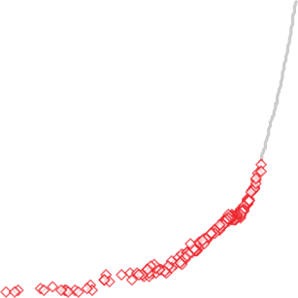

Atmospheric measurements (ML)

Law Dome

390

370

350

**CO2/ppm**

330

310

290

270

250

1000 1200 1400

**Year**

1600 1800 2000

**Figure B3.** CO2 variations during the past 1,000 years, obtained from analysis of air trapped in an ice core extracted from Antarctica (red squares), show a sharp rise in

atmospheric CO2 starting in the late 19th century. Modern atmospheric measurements from Mauna Loa are superimposed in gray. *Source: figure by Eric Wolff, data from Etheridge et al.,*

*1996; MacFarling Meure et al., 2006; Scripps CO2 Program.*

**Learn about the sources of human-emitted greenhouse gases:**



* + **Carbon dioxide (CO2)** has both natural and human sources, but CO2 levels are increasing primarily because of the combustion of fossil fuels, cement production, defor- estation (which reduces the CO2 taken up by trees and increases the CO2 released by decomposition of the detritus), and other land use changes. Increases in CO2 are the single largest contributor to global warming.
* **Methane (CH4)** has both human and natural sources, and levels have risen significantly since

pre-industrial times due to human activities such as raising livestock, growing paddy rice, filling landfills, and using natural gas (which is mostly CH4, some of which may be released when it is extracted, transported, and used).

* **Nitrous oxide (N2O)** concentra- tions have risen primarily because of agricultural activities such as the use of nitrogen-based fertilisers and land use changes.
* **Halocarbons**, including chloro- fluorocarbons (CFCs), are chem- icals used as refrigerants and fire retardants. In addition to being potent greenhouse gases, CFCs also damage the ozone layer. The production of most CFCs has now been banned, so their impact is starting to decline. However, many CFC replacements are also potent greenhouse gases and their concen- trations and the concentrations

of other halocarbons continue to increase.

Evidence & Causes 2 02 0 ***B3***

##### basics of climate change

Measurements of the forms (isotopes) of carbon in the modern atmosphere show a clear fingerprint of the addition of “old” carbon (depleted in natural radioactive 14C) coming from the combustion of fossil fuels (as opposed to “newer” carbon coming from living systems). In addition, it is known that human activities (excluding land use changes) currently emit an estimated 10 billion tonnes of carbon each year, mostly by burning fossil fuels, which is more than enough to explain the observed increase in concentration.

These and other lines of evidence point conclusively to the fact that the elevated CO2 concentration in our atmosphere is the result of human activities.

### Climate records show a warming trend.

Estimating global average surface air temperature increase requires careful analysis of millions of measurements from around the world, including from land stations, ships, and satellites. Despite the many complications of synthesising such data, multiple

independent teams have concluded separately and unanimously that global average surface air temperature has risen by about 1 °C (1.8 °F) since 1900 **[Figure B4].** Although the record shows several pauses and accelerations in the increasing trend, each of the last four decades has been warmer than any other decade in the instrumental record since 1850.

Going further back in time before accurate thermometers were widely available, temperatures can be reconstructed using climate-sensitive indicators “proxies”

**Learn about the ice ages:**

Detailed analyses of ocean sediments, ice cores, and other data show that for at least the last 2.6 million years, Earth has gone through extended periods when temperatures were much lower than today and thick blankets of ice covered large areas of the Northern Hemisphere. These long cold spells, lasting in the most recent cycles for around 100,000 years, were interrupted by shorter warm ‘interglacial’ periods, including the past 10,000 years.

Through a combination of theory, observations, and modelling, scientists have deduced that the ice ages* are triggered by recurring variations in Earth’s orbit that primarily alter the regional and seasonal distribution of solar energy reaching Earth. These relatively small changes in solar energy are reinforced over thousands of years by gradual changes in Earth’s ice cover (the cryosphere), especially over the Northern Hemisphere, and in atmospheric composition, eventually leading to large

changes in global temperature.

The average global temperature change during an ice-age cycle is estimated as 5

°C ± 1 °C (9 °F ± 2 °F).

*\*Note that in geological terms Earth has been in an ice age ever since the Antarctic Ice Sheet last formed about 36 million years ago. However, in this document we have used the term in its more colloquial usage indicating the regular occurrence of extensive ice sheets over North America and northern Eurasia.*

***B4*** Climate

Change

##### basics of climate change

in materials such as tree rings, ice cores, and marine sediments. Comparisons of the thermometer record with these proxy measurements suggest that the time since the early 1980s has been the warmest 40-year period in at least eight centuries, and that global temperature is rising towards peak temperatures last seen 5,000 to 10,000 years ago in the warmest part of our current interglacial period*.*

Many other impacts associated with the warming trend have become evident in recent years. Arctic summer sea ice cover has shrunk dramatically. The heat content of the ocean has increased. Global average sea level has risen by approximately 16 cm (6 inches) since 1901, due both to the expansion of warmer ocean water and to the addition of melt waters from glaciers and ice sheets on land. Warming and precipitation changes are altering the geographical ranges of many plant and animal species and the timing of their life cycles. In addition to the effects on climate, some of the excess CO2 in the atmosphere is being taken up by the ocean, changing its chemical composition (causing ocean acidification).

1

0.8

**Difference from average temperature (°C) relative to 1961-1990**

0.6

0.4

0.2

0

-0.2

-0.4

-0.6

-0.8

0.6

0.4

0.2

0

-0.2

-0.4

-0.6

**Annual average**

Hadley Centre (UK Met)

**Figure B4.** Earth’s global average surface temperature has risen, as shown in this plot of combined land and ocean measurements from 1850 to 2019 derived from three independent analyses of the available data sets. The top panel shows annual average values from the three analyses, and the bottom panel shows decadal average values, including the uncertainty range (grey bars) for the maroon (HadCRUT4) dataset. The tem- perature changes are relative to the global average surface temperature, averaged from 1961−1990. *Source: NOAA Climate.gov, based on IPCC AR5.*

*Data from UK Met Office Hadley Centre (maroon), US National Aeronautics and Space Administration Goddard Institute for Space Studies (red), and US National Oceanic and Atmospheric Administration*

NASA (GISS) NOAA (NCEI)

**1961−1990 average**

**Decadal average**

*National Centers for Environmental Infor-*

1850 1870 1890 1910 1930 1950 1970 1990 2010

**Year**

*mation (orange).*

Evidence & Causes 2 02 0 ***B5***

##### basics of climate change

***B6*** Climate

Change

### Many complex processes shape our climate.

Based just on the physics of the amount of energy that CO2 absorbs and emits, a doubling of atmospheric CO2 concentration from pre-industrial levels (up to about 560 ppm) would by itself cause a global average temperature increase of about 1 °C (1.8 °F). In the overall climate system, however, things are more complex; warming leads to further effects (feedbacks) that either amplify or diminish the initial warming.

The most important feedbacks involve various forms of water. A warmer atmosphere generally contains more water vapour. Water vapour is a potent greenhouse gas, thus causing more warming; its short lifetime in the atmosphere keeps its increase largely in step with warming. Thus, water vapour is treated as an amplifier, and not a driver, of climate change. Higher temperatures in the polar regions melt sea ice and reduce seasonal snow cover, exposing a darker ocean and land surface that can absorb more heat, causing further warming. Another important but uncertain feedback concerns changes in clouds. Warming and increases in water vapour together may cause cloud cover to increase or decrease which can either amplify or dampen temperature change depending on the changes in the horizontal extent, altitude, and properties of clouds. The latest assessment of the science indicates that the overall net global effect of cloud changes is likely to be to amplify warming.

The ocean moderates climate change. The ocean is a huge heat reservoir, but it is difficult to heat its full depth because warm water tends to stay near the surface. The rate at which heat is transferred to the deep ocean is therefore slow; it varies from year to year and from decade to decade, and it helps to determine the pace of warming at the surface. Observations of the

sub-surface ocean are limited prior to about 1970, but since then, warming of the upper 700 m (2,300 feet) is readily apparent, and deeper warming is also clearly observed since about 1990.

Surface temperatures and rainfall in most regions vary greatly from the global average because of geographical location, in particular latitude and continental position. Both the average values of temperature, rainfall, and their extremes (which generally have the largest impacts on natural systems and human infrastructure), are also strongly affected by local patterns of winds.

Estimating the effects of feedback processes, the pace of the warming, and regional climate change requires the use of mathematical models of the atmosphere, ocean, land, and ice (the cryosphere) built upon established laws of physics and the latest understanding of the

physical, chemical and biological processes affecting climate, and run on powerful computers. Models vary in their projections of how much additional warming to expect (depending on the type of model and on assumptions used in simulating certain climate processes, particularly cloud formation and ocean mixing), but all such models agree that the overall net effect of feedbacks is to amplify warming.

basics of climate change

### Human activities are changing the climate.

Rigorous analysis of all data and lines of evidence shows that most of the observed global warming over the past 50 years or so cannot be explained by natural causes and instead requires a significant role for the influence of human activities.

In order to discern the human influence on climate, scientists must consider many natural variations that affect temperature, precipitation, and other aspects of climate from local to global scale, on timescales from days to decades and longer. One natural variation is the El Niño Southern Oscillation (ENSO), an irregular alternation between warming and cooling (lasting about two to seven years) in the equatorial Pacific Ocean that causes significant year-to-year regional and global shifts in temperature and rainfall patterns. Volcanic eruptions also alter climate, in part increasing the amount of small (aerosol) particles in the stratosphere that reflect or absorb sunlight, leading to a short-term surface cooling lasting typically about two to three years. Over hundreds of thousands of years, slow, recurring variations in Earth’s orbit around the Sun, which alter the distribution of solar energy received by Earth, have been enough to trigger the ice age cycles of the past 800,000 years.

Fingerprinting is a powerful way of studying the causes of climate change. Different influences on climate lead to different patterns seen in climate records. This becomes obvious when scientists probe beyond changes in the average temperature of the planet and look more closely at geographical and temporal patterns of climate change. For example, an increase

in the Sun’s energy output will lead to a very different pattern of temperature change (across Earth’s surface and vertically in the atmosphere) compared to that induced by an increase in CO2 concentration. Observed atmospheric temperature changes show a fingerprint much

*continued*

**Learn more about other human causes of climate change:**

In addition to emitting greenhouse gases, human activities have also altered Earth’s energy balance through, for example:

* + **Changes in land use.** Changes in the way people use land — for example, for forests, farms, or cities — can

lead to both warming and cooling effects locally by changing the reflectivity of

Earth’s surfaces (affecting how much sunlight is sent back into space) and by changing how wet a region is.

* **Emissions of pollutants (other than greenhouse gases)**. Some industrial and agricultural processes emit pollutants that produce aerosols (small droplets or particles suspended in the atmosphere). Most aerosols cool Earth by

reflecting sunlight back to space. Some aerosols also affect the formation of clouds, which can have a warming or cooling

effect depending on their type and location. Black carbon particles (or “soot”) produced when fossil fuels or vegetation are burned generally have a warming effect because they absorb incoming solar radiation.

Evidence & Causes 2 02 0 ***B7***

##### basics of climate change

closer to that of a long-term CO2 increase than to that of a fluctuating Sun alone. Scientists routinely test whether purely natural changes in the Sun, volcanic activity, or internal climate variability could plausibly explain the patterns of change they have observed in many different aspects of the climate system. These analyses have shown that the observed climate changes of the past several decades cannot be explained just by natural factors.

**Figure B5.** The amount and rate of warming expected for the 21st cen- tury depends on the total amount of greenhouse gases that humankind emits. Models project the tempera- ture increase for a business-as-usual emissions scenario (in red) and aggressive emission reductions, falling close to zero 50 years from now (in blue). Black is the modelled estimate of past warming. Each solid line represents the average

of different model runs using the same emissions scenario, and the shaded areas provide a measure of the spread (one standard deviation) between the temperature changes projected by the different models. All data are relative to a reference period (set to zero) of 1986-2005. *Source: Based on IPCC AR5*

### How will climate change in the future?

Scientists have made major advances in the observations, theory, and modelling of Earth’s climate system, and these advances have enabled them to project future climate change with increasing confidence. Nevertheless, several major issues make it impossible to give precise estimates of how global or regional temperature trends will evolve decade by decade into the future. Firstly, we cannot predict how much CO2 human activities will emit, as this depends on factors such as how the global economy develops and how society’s production and consumption of energy changes in the coming decades. Secondly, with current understanding of the complexities of how climate feedbacks operate, there is a range of possible outcomes, even for a particular scenario of CO2 emissions. Finally, over timescales of a decade or so, natural variability can modulate the effects of an underlying trend in temperature. Taken together, all model projections indicate that Earth will continue to warm considerably more over the next few decades to centuries. If there were no technological or policy changes to reduce emission trends from their current trajectory, then further globally- averaged warming of 2.6 to 4.8 °C (4.7 to 8.6 °F) in addition to that which has already

occurred would be expected during the 21st century **[Figure B5].** Projecting what those ranges will mean for the climate experienced at any particular location is a challenging scientific problem, but estimates are continuing to improve as regional and local-scale models advance.

Global average surface temperature change

6.0

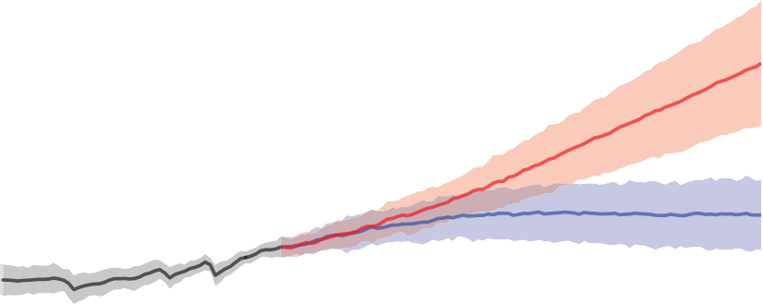

Modelled past warming Aggressive emissions reductions “Business as usual” emissions

Difference from average temperature (°C)

4.0

2.0

0.0

−2.0

1950 2000 2050 2100

***B8*** Climate

Change

## If the world is warming, why are some winters and summers still very cold?

Global warming is a long-term trend, but that does not mean that every year will be warmer than the previous one. Day-to-day and year-to-year changes in weather patterns will continue to produce some unusually cold days and nights and winters and summers, even as the climate warms.

11

Climate change means not only changes in globally averaged surface temperature, but also changes in atmospheric circulation, in the size and patterns of natural climate variations, and in local weather. La Niña events shift weather patterns so that some regions are made wetter, and wet summers are generally cooler. Stronger winds from polar regions can contribute to an occasional colder winter. In a similar way, the persistence of one phase of an atmospheric circulation pattern known as the North Atlantic Oscilla- tion has contributed to several recent cold winters in Europe, eastern North America, and northern Asia.

Atmospheric and ocean circulation patterns will evolve as Earth warms and will influence storm tracks and many other aspects of the weather. Global warming tilts the odds in favour of more warm days and seasons and fewer cold days and seasons. For example, across the continental United States in the 1960s there were more daily record low temperatures than record highs, but in the 2000s there were more than twice as many record highs as record lows. Another important example of tilting the odds is that over recent decades heatwaves have increased in frequency in large parts of Europe, Asia, South America, and Australia. Marine heat waves are also increasing.

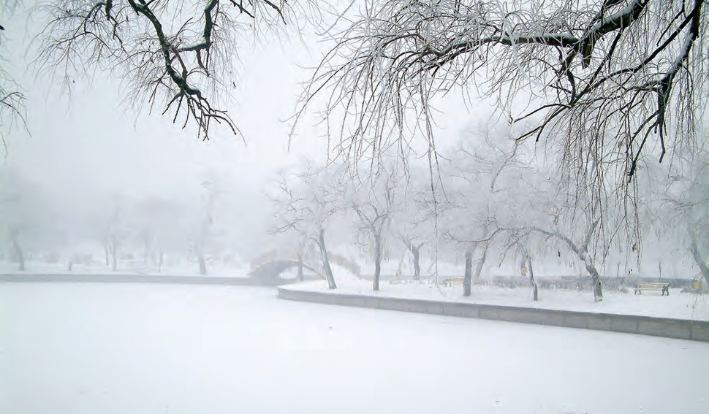

## Why is Arctic sea ice decreasing while Antarctic sea ice has changed little?

Sea ice extent is affected by winds and ocean currents as well as temperature. Sea ice in the partly-enclosed Arctic Ocean seems to be responding directly to warming, while

changes in winds and in the ocean seem to be dominating the patterns of climate and sea ice change in the ocean around Antarctica.

12

**Figure 5.** The Arctic summer sea ice extent in 2012, (measured in September) was a record low, shown (in white) compared to the median summer sea ice extent for

1979 to 2000 (in orange outline). In 2013, Arctic summer sea ice extent rebounded somewhat, but was still the sixth smallest extent on record. In 2019, sea ice extent effectively tied for the second lowest minimum in the satellite record, along with 2007 and 2016—behind only 2012, which is still the record minimum. The 13 lowest ice extents in the satellite era have all occurred in the last 13 years. *Source: National Snow and Ice Data Center*

Some differences in seasonal sea ice extent between the Arctic and Antarctic are due to basic geography and its influence on atmospheric and oceanic circulation. The Arctic is an ocean basin surrounded largely by mountainous continental land masses, and Antarctica is a continent surrounded by ocean. In the Arctic, sea ice extent is limited by the surrounding land masses. In the Southern Ocean winter, sea ice can expand freely into the surrounding ocean, with its southern boundary set by the coastline of Antarctica. Because Antarctic Sea ice forms at latitudes further from the South Pole (and closer to the equator), less ice survives the summer. Sea ice extent in both poles changes seasonally; however, longer-term variability in summer and winter ice extent is different in each hemisphere, due in part to these basic geographical differences.

Sea ice in the Arctic has decreased dramatically since the late 1970s, particularly in summer and autumn. Since the satellite record began in 1978, the yearly minimum Arctic sea ice extent (which occurs in September) has decreased by about 40% **[Figure 5]**. Ice cover expands again each Arctic winter, but

the ice is thinner than it used to be. Estimates of past sea ice extent suggest that this decline may be unprecedented in at least the past 1,450 years. Because sea ice is highly reflective, warming is amplified as the ice decreases and more sunshine is absorbed by the darker underlying ocean surface.

Sea ice in the Antarctic showed a slight increase in overall extent from 1979 to 2014, although some areas, such as that to the west of the Antarctic Peninsula experienced a decrease. Short-term trends in

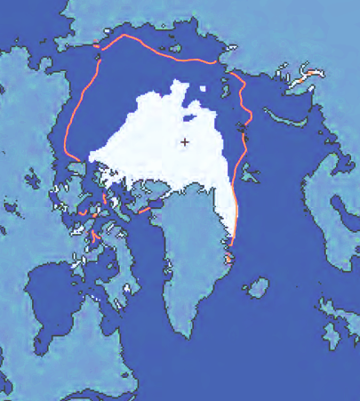the Southern Ocean, such as those observed, can readily occur from natural variability of the atmosphere, ocean and sea ice system. Changes in surface wind patterns around the continent contributed to the Antarctic pattern of sea ice

change; ocean factors such as the addition of cool fresh water from melting ice shelves may also have played a role. However, after 2014, Antarctic ice extent began to decline, reaching a record low (within the 40 years of satellite data) in 2017, and remaining low in the following two years.

## How does climate change affect the strength and frequency of floods, droughts, hurricanes, and tornadoes?

Earth’s lower atmosphere is becoming warmer and moister as a result of human-caused greenhouse gas emissions. This gives the potential for more energy for storms and certain extreme weather events. Consistent with theoretical expectations, the types of events most closely related to temperature, such as heatwaves and extremely hot days, are becoming more likely. Heavy rainfall and snowfall events (which increase the risk of flooding) are also generally becoming more frequent.

13

As Earth’s climate has warmed, more frequent and more intense weather events have both been observed around the world. Scientists typically identify these weather events as “extreme” if they are unlike 90% or 95% of similar weather events that happened before in the same region. Many factors contribute to any individual extreme weather event—including patterns of natural climate variability, such as El Niño and La Niña— making it challenging to attribute any particular extreme event to human-caused climate change. However, studies can show whether the warming climate made an event more severe or more likely to happen.

A warming climate can contribute to the intensity of heat waves by increasing the chances of very hot days and nights. Climate warming also increases evaporation on land, which can worsen drought and create conditions more prone to wildfire and a longer wildfire season. A warming atmosphere is also associated with heavier precipitation events (rain and snowstorms) through increases in the air’s capacity to hold moisture. El Niño events favour drought in many tropical and subtropical land areas, while La Niña events promote wetter conditions in many places. These short-term and regional variations are expected to become more extreme in a warming climate.

Earth’s warmer and moister atmosphere and warmer oceans make it likely that the strongest hurricanes will be more intense, produce more rainfall, affect new areas, and possibly be larger and longer-lived. This is supported by available observational evidence in the North Atlantic. In addition, sea level rise (see Question 14) increases the amount of seawater that is pushed on to shore during coastal storms, which, along with more rainfall produced by the storms, can result in more destructive storm surges and flooding. While global warming is likely making hurricanes more intense, the change in the number of hurricanes each year is quite uncertain. This remains a subject of ongoing research.

Some conditions favourable for strong thunderstorms that spawn tornadoes are expected to increase with warming, but uncertainty exists in other factors that affect tornado formation, such as changes in the vertical and horizontal variations of winds.

## How fast is sea level rising?

Long-term measurements of tide gauges and recent satellite data show that global sea level is rising, with the best estimate of the rate of global-average rise over the last decade being 3.6 mm per year (0.14 inches per year). The rate of sea level rise has increased since measurements using altimetry from space were started in 1992; the dominant factor in global-average sea level rise since 1970 is human-caused warming. The overall observed rise since 1902 is about 16 cm (6 inches) **[Figure 6]**.

14

**Figure 6.** Observations show that the global average sea level

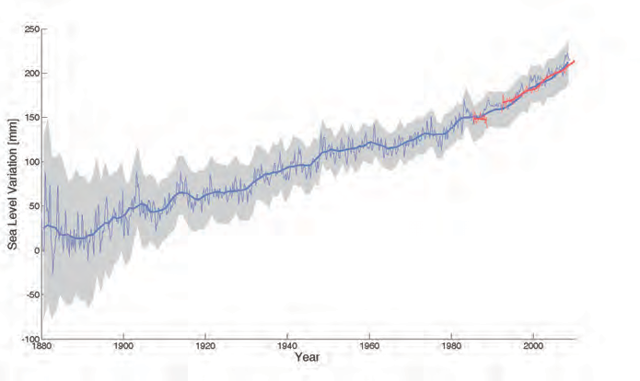has risen by about 16 cm (6 inches) since the late 19th century. Sea level is rising faster in recent decades; measurements from tide gauges (blue) and satellites (red) indicate that the best estimate for the average sea level rise over the last decade is centred on 3.6 mm per year (0.14 inches per year). The shaded area represents the sea level uncertainty, which has decreased

as the number of gauge sites used in calculating the global averages and the number of data points have increased. *Source: Shum and Kuo (2011)*

This sea level rise has been driven by expansion of water volume as the ocean warms, melting of mountain glaciers in all regions of the world, and mass losses from the Greenland and Antarctic ice sheets. All of these result from a warming climate. Fluctuations in sea level also occur due to changes in the amounts of water stored on land. The amount of sea level change experienced at any given location also depends on a variety of other factors, including whether regional geological processes and rebound of the land weighted down by previous ice sheets are causing the land itself to rise or sink, and whether changes in winds and currents are piling ocean water against some coasts or moving water away.

The effects of rising sea level are felt most acutely in the increased frequency and intensity of occasional storm surges. If CO2 and other greenhouse gases continue to increase on their current trajectories, it is projected that sea level may rise, at minimum, by a further 0.4 to 0.8 m (1.3 to 2.6 feet) by 2100, although future ice sheet melt could make these values considerably higher. Moreover, rising sea levels will not stop in 2100; sea levels will be much higher in the following centuries as the sea continues to take up heat and glaciers continue to retreat. It remains difficult to predict the details of how the Greenland and Antarctic Ice Sheets will respond to continued warming, but it is thought that Greenland and perhaps West Antarctica will continue to lose mass, whereas the colder parts of Antarctica could gain mass as they receive more snowfall from warmer air that contains more moisture. Sea level in the last interglacial

(warm) period around 125,000 years ago peaked at probably 5 to 10 m above the present level. During this period, the polar regions were warmer than they are today. This suggests that, over millennia, long periods of increased warmth will lead to very significant loss of parts of the Greenland and Antarctic Ice Sheets and to consequent sea level rise.

## What is ocean acidification and why

15

does it matter?

Direct observations of ocean chemistry have shown that the chemical balance of seawater has shifted to a more acidic state (lower pH) **[Figure 7]**. Some marine organisms (such as corals and some shellfish) have shells composed of calcium carbonate, which dissolves more readily in acid. As the acidity of sea water increases, it becomes more difficult for these organisms to form or maintain their shells.

CO2 dissolves in water to form a weak acid, and the oceans have absorbed about a third of the CO2 resulting from human activities, leading to a steady decrease in ocean pH levels. With increasing atmospheric CO2, this chemical balance will change even more during the next century. Laboratory and other experiments show that under high CO2 and in more acidic waters, some marine species have misshapen shells and lower growth rates, although the effect varies among species. Acidification also alters the cycling of nutrients and many other elements and compounds in the ocean, and it is likely to shift the competitive advantage among species, with as-yet-to-be-determined impacts on marine ecosystems and the food web.

**figure 7.** As CO2 in the air has increased, there has been an increase in the CO2 content of the surface ocean (upper box), and a decrease in the seawater pH (lower box). *Source: adapted from Dore et al. (2009) and Bates et al. (2012).*

400

390

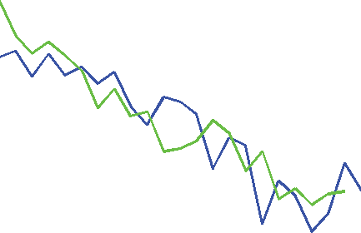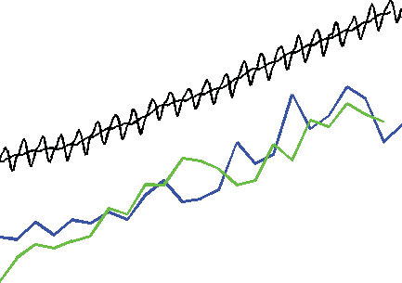

Atmospheric CO2 concentration (ppm)

Surface Ocean *p*CO2, Bermuda (µatm)

Surface Ocean *p*CO2, Hawaii (µatm)

Surface Ocean pH

Bermuda

Hawaii

380

*p*CO2 or CO2 concentration

370

360

350

340

330

320

1990 1995 2000 2005 2010

Year

8.11

8.10

8.09

pH

8.08

8.07

8.06

# 16

**figure 8.** If emissions continue on their present trajectory, without either technological or regulatory abatement, then the best estimate is that global average temperature will warm a further 2.6 to 4.8 °C (4.7 to 8.6 °F) by the end of the century (right). Land areas are projected to warm more than ocean areas and hence more than the global mean. The figure on the left shows projected warming with very aggressive emissions reductions. The figures represent multi-model estimates of temperature averages for 2081-2100 compared to 1986–2005. *Source: IPCC AR5*

## How confident are scientists that earth will warm further over the coming century?

Very confident. If emissions continue on their present trajectory, without either technologi- cal or regulatory abatement, then warming of 2.6 to 4.8 °C (4.7 to 8.6 °F) in addition to that which has already occurred would be expected during the 21st century **[Figure 8]**.

Warming due to the addition of large amounts of greenhouse gases to the atmosphere can be understood in terms of very basic properties of greenhouse gases. It will in turn lead to many changes in natural climate processes, with a net effect of amplifying the warming. The size of the warming that will be experienced depends largely on the amount of greenhouse gases accumulating in the atmosphere and hence on the trajectory of emissions. If the total cumulative emissions since 1875 are kept below about 900 gigatonnes (900 billion tonnes) of carbon, then there is a two-thirds chance of keeping the rise in global average temperature since the pre-industrial period below 2 °C (3.6 °F). However, two-thirds of this amount has already been emitted. A target of keeping global average temperature rise below 1.5 °C (2.7 °F) would allow for even less total cumulative emissions since 1875.

Based just on the established physics of the amount of heat CO2 absorbs and emits, a doubling of atmospheric CO2 concentration from preindustrial levels (up to about 560 ppm) would by itself, without amplification by any other effects, cause a global average temperature increase of about 1 °C (1.8 °F).

However, the total amount of warming from a given amount of emissions depends on chains of effects (feedbacks) that can individually either amplify or diminish the initial warming.

The most important amplifying feedback is caused by water vapour, which is a potent greenhouse gas. As CO2 increases and warms the atmosphere, the warmer air can hold more moisture and trap more heat in the lower atmosphere. Also, as Arctic sea ice and glaciers melt, more sunlight is absorbed into the darker underlying land and ocean surfaces, causing further warming and further melting of ice and snow. The biggest uncertainty in our understanding of feedbacks relates to clouds (which can have both positive and negative feedbacks), and how the properties of clouds will change in response to climate change.

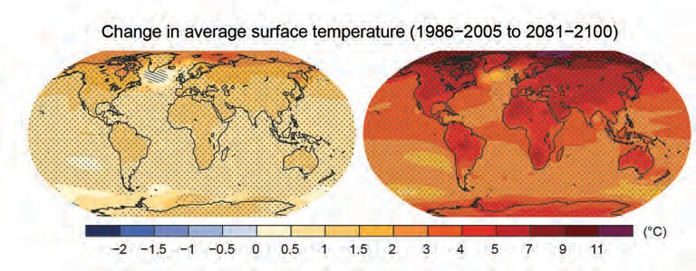Other important feedbacks involve the carbon cycle. Currently the land and oceans together absorb about half of the CO2 emitted from human activities, but the capacities of land and ocean to store additional carbon are

expected to decrease with additional warming, leading to faster increases in atmospheric

CO2 and faster warming. Models vary in their projections of how much additional warming to expect, but all such models agree that the overall net effect of feedbacks is to amplify the warming.

## Are climate changes of a few degrees a cause for concern?

Yes. Even though an increase of a few degrees in global average temperature does not sound like much, global average temperature during the last ice age was only about 4 to 5 °C (7 to 9 °F) colder than now. Global warming of just a few degrees will be associated with widespread changes in regional and local temperature and precipitation as well as with increases in some types of extreme weather events. These and other changes (such as sea level rise and storm surge) will have serious impacts on human societies and the natural world.

17

Both theory and direct observations have confirmed that global warming is associated with greater warming over land than oceans, moistening of the atmosphere, shifts in regional precipitation patterns, increases in extreme weather events, ocean acidification, melting glaciers, and rising sea levels (which increases the risk of coastal inundation and storm surge). Already, record high temperatures are on average significantly outpacing record low temperatures, wet areas are becoming wetter as dry areas are becoming drier, heavy rainstorms have become heavier, and snowpacks (an important source of freshwater for many regions) are decreasing.

These impacts are expected to increase with greater warming and will threaten food production, freshwater supplies, coastal infrastructure, and especially the welfare of the huge population currently living in low-lying areas. Even though certain regions may realise some local benefit from the warming, the long-term consequences overall will be disruptive.

It is not only an increase of a few degrees in global average temperature that is cause for concern—the pace at which this warming occurs is also important (see Question 6). Rapid human-caused climate changes mean that less time is available to allow for adaptation measures to be put in place or for ecosystems to adapt, posing greater risks in areas vulnerable to more intense extreme weather events and rising sea levels.

## What are scientists doing to address key uncertainties in our

18

understanding of the climate system?

Science is a continual process of observation, understanding, modelling, testing, and prediction. The prediction of a long-term trend in global warming from increasing greenhouse gases is robust and has been confirmed by a growing body of evidence. Nevertheless, understanding of certain aspects of climate change remains incomplete. Examples include natural climate variations on decadal-to-centennial timescales and regional-to-local spatial scales and cloud responses to climate change, which are all areas of active research.

*continued*

Comparisons of model predictions with observations identify what is well-understood and, at the same time, reveal uncertainties or gaps in our understanding. This helps to set priorities for new research. Vigilant monitoring of the entire climate system—the atmosphere, oceans, land, and ice—is therefore critical, as the climate system may be full of surprises.

**Why are computer models used to study climate change?**

The future evolution of Earth’s climate as it responds to the present rapid rate of increasing atmospheric CO2 has no precise analogues in the past, nor can it be properly understood through laboratory experiments. As we are also unable to carry out deliberate controlled experiments on Earth itself, computer models are among the most important tools used to study Earth’s climate system.

Climate models are based on mathematical equations that represent the best understanding of the basic laws of physics, chemistry, and biology that govern the behaviour of the atmosphere, ocean, land surface, ice, and other parts of the climate system, as well as the interactions among them. The most comprehensive climate models, Earth-System Models, are designed to simulate Earth’s climate system with as much detail as is permitted by our understanding and by available supercomputers.

The capability of climate models has improved steadily since the 1960s. Using physics-based equations, the models can be tested and are successful in simulating a broad range of weather and climate variations, for example from individual storms, jet stream meanders, El Niño events, and the climate of the last century.

Their projections of the most prominent features of the long-term human-induced climate change signal have remained robust, as generations of increasingly complex models yield richer details of the change. They are also

used to perform experiments to

isolate specific causes of climate change

and to explore the consequences of different scenarios of future greenhouse gas emissions and other influences on climate.

Together, field and laboratory data and theoretical understanding are used to advance models of Earth’s climate system and to improve representation of key processes in them, especially those associated with clouds, aerosols,

and transport of heat into the oceans. This is critical for accurately simulating climate change and associated changes in severe weather, especially at the regional and local scales important for policy decisions.

Simulating how clouds will change with warming and in turn may affect warming remains one of the major challenges for global climate models, in part because different cloud types have different impacts on climate, and the many cloud processes occur on scales smaller than most current models can resolve. Greater computer power is already allowing for some of these processes to be resolved in the new generation of models.

Dozens of groups and research institutions work on climate models, and scientists are now able to analyse results from essentially all of the world’s major Earth-System Models and compare them with each other and with observations. Such opportunities are of tremendous benefit in bringing out the strengths and weaknesses of various models and diagnosing the causes of differences among models, so that research can focus on the relevant processes. Differences among models allow

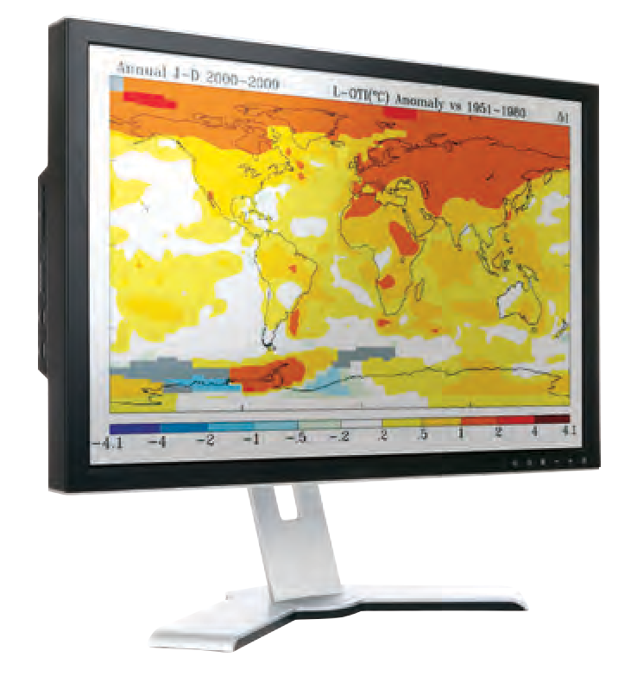estimates to be made of the uncertainties in projections of future climate change. Additionally, large archives of results from many different models help scientists to identify aspects of climate change projections that are robust and that can be interpreted in terms of known physical mechanisms.

Studying how climate responded to major changes in the past is another way of checking that we understand how different processes work and that models are capable of performing reliably under a wide range of conditions.

## Are disaster scenarios about tipping points like “turning off the Gulf Stream” and release of methane from the Arctic a cause for concern?

19

Results from the best available climate models do not predict an abrupt change in (or collapse of) the Atlantic Meridional Overturning Circulation, which includes the Gulf Stream, in the near future. However, this and other potential high-risk abrupt changes, like the release of methane and carbon dioxide from thawing permafrost, remain active areas of scientific research. Some abrupt changes are already underway, such as the decrease in Arctic sea ice extent (see Question 12), and as warming increases, the possibility of other major abrupt changes cannot be ruled out.

The composition of the atmosphere is changing towards conditions that have not been experienced for millions of years, so we are headed for unknown territory, and uncertainty is large. The climate system involves many competing processes that could switch the climate into a different state once a threshold has been exceeded.

A well-known example is the south-north ocean overturning circulation, which is maintained by cold salty water sinking in the North Atlantic and involves the transport of extra heat to the North Atlantic via the Gulf Stream. During the last ice age, pulses of freshwater from the melting ice sheet over North America led to slowing down of this overturning circulation. This in turn caused widespread changes in climate around the Northern Hemisphere. Freshening of the North Atlantic from the melting of the Greenland ice sheet is gradual, however, and hence is not expected to cause abrupt changes.

Another concern relates to the Arctic, where substantial warming could destabilise methane (a greenhouse gas) trapped in ocean sediments and permafrost, potentially leading to a rapid release of a large amount of methane. If such a rapid release occurred, then major, fast climate changes would

ensue. Such high-risk changes are considered unlikely in this century, but are by definition hard to predict. Scientists are therefore continuing to study the possibility of exceeding such tipping points, beyond which we risk large and abrupt changes.

In addition to abrupt changes in the climate system itself, steady climate change can cross thresholds that trigger abrupt changes in other systems. In human systems, for example, infrastructure has typically been built to accommodate the climate variability at the time of construction. Gradual climate changes can cause abrupt changes in the utility of the infrastructure—such as when rising sea levels suddenly surpass sea walls, or when thawing permafrost causes the sudden collapse of pipelines, buildings, or roads. In natural systems, as air and water temperatures rise, some species—such as the mountain pika and many ocean corals—will no longer be able to survive in their current habitats and will be forced to relocate (if possible) or rapidly adapt. Other species may fare better in the new conditions, causing abrupt shifts in the balance of ecosystems; for example, warmer temperatures have allowed more bark beetles to survive over winter in some regions, where beetle outbreaks have destroyed forests.

# 20

**figure 9.** If global emissions were to suddenly stop, it would take a long time for surface air temperatures and the ocean to begin to cool because the excess CO2 in the atmosphere would remain there for a long time and would continue to exert a warming

effect. Model projections show how atmospheric CO2 concentration

(a), surface air temperature (b), and ocean thermal expansion (c) would respond following a scenario of business-as-usual emissions ceasing in 2300 (red), a scenario

of aggressive emission reductions, falling close to zero 50 years from now (orange), and two intermediate emissions scenarios (green and blue). The small downward tick

in temperature at 2300 is caused by the elimination of emissions of short-lived greenhouse gases,

including methane. *Source: Zickfeld et al., 2013*

## If emissions of greenhouse gases were stopped, would the climate return to the conditions of 200 years ago?

No. Even if emissions of greenhouse gases were to suddenly stop, Earth’s surface temperature would require thousands of years to cool and return to the level in the pre-industrial era.

If emissions of CO2 stopped altogether, it would take many thousands of years for atmospheric CO2 to return to “pre-industrial” levels due to its very slow transfer to the deep ocean and ultimate burial in ocean sediments. Surface temperatures would stay elevated for at least a thousand years, implying a long-term commitment to a warmer planet due to past and current emissions. Sea level would likely continue

to rise for many centuries even after temperature stopped increasing **[Figure 9]**. Significant cooling would be required to reverse melting of glaciers and the Greenland ice sheet, which formed during past cold climates. The current CO2-induced warming of Earth is therefore essentially irreversible on human timescales. The amount and rate of further warming will depend almost entirely on how much more CO2 humankind emits.

Scenarios of future climate change increasingly assume the use of technologies that can remove green- house gases from the atmosphere. In such “negative emissions” scenarios, it assumed that at some point

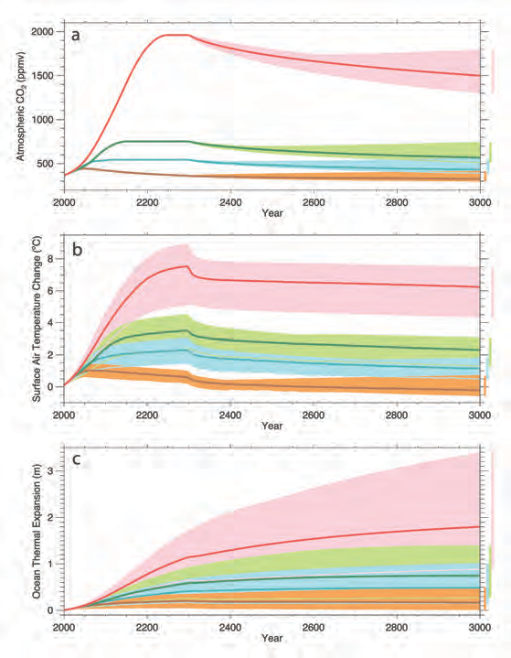in the future, widespread effort will be undertaken that utilises such technologies to remove CO2 from the atmosphere and lower its atmospheric concentra- tion, thereby starting to reverse CO2-driven warming on longer timescales. Deployment of such technologies at scale would require large decreases in their costs. Even if such technological fixes were practical, substantial reductions in CO2 emissions would still be essential.

Conclusion

This document explains that there are well-understood physical mechanisms by which changes in the amounts of greenhouse gases cause climate changes. It discusses the evidence that the concentrations of these gases in the atmosphere have increased and are still increasing rapidly, that climate change is occurring, and that most of the recent change is almost certainly due to emissions of greenhouse gases caused by human activities. Further climate change is inevitable; if emissions of greenhouse gases continue unabated, future changes will substantially exceed those that have occurred so far. There remains a range of estimates of the magnitude and regional expression of future change, but increases in the extremes of climate that can adversely affect natural ecosystems and human activities and infrastructure are expected.

Citizens and governments can choose among several options (or a mixture of those options) in response to this information: they can change their pattern of energy production and usage in order to limit emissions of greenhouse gases and hence the magnitude of climate changes; they can wait for changes to occur and accept the losses, damage, and suffering that arise; they can adapt to actual and expected changes as much as possible; or they can seek as yet unproven “geoengineering” solutions to counteract some of the climate changes that would otherwise occur. Each of these options has

risks, attractions and costs, and what is actually done may be a mixture of these different options. Different nations and communities will vary in their vulnerability and their capacity to adapt. There is an important debate to be had about choices among these options, to decide what is best for each group or nation, and most importantly for the global population as a whole. The options have to be discussed at a global scale because in many cases those communities that are most vulnerable control few of the emissions, either past or future. Our description of the science of climate change, with both its facts and its uncertainties, is offered as a basis to inform that policy debate.

* + acknowledgements

**Authors**

The following individuals served as the primary writing team for the 2014 and 2020 editions of this document:

* + - Eric Wolff FRS, (UK lead), University of Cambridge
    - Inez Fung (NAS, US lead), University of California, Berkeley
    - Brian Hoskins FRS, Grantham Institute for Climate Change
    - John F.B. Mitchell FRS, UK Met Office
    - Tim Palmer FRS, University of Oxford
    - Benjamin Santer (NAS), Lawrence Livermore National Laboratory
* John Shepherd FRS, University of Southampton
* Keith Shine FRS, University of Reading.
* Susan Solomon (NAS), Massachusetts Institute of Technology
* Kevin Trenberth, National Center for Atmospheric Research
* John Walsh, University of Alaska, Fairbanks
* Don Wuebbles, University of Illinois

Staff support for the 2020 revision was provided by Richard Walker, Amanda Purcell, Nancy Huddleston, and Michael Hudson. We offer special thanks to Rebecca Lindsey and NOAA Climate.gov for providing data and figure updates.

#### Reviewers

The following individuals served as reviewers of the 2014 document in accordance with procedures approved by the Royal Society and the National Academy of Sciences:

* + Richard Alley (NAS), Department of Geosciences, Pennsylvania State University
  + Alec Broers FRS, Former President of the Royal Academy of Engineering
  + Harry Elderfield FRS, Department of Earth Sciences, University of Cambridge
  + Joanna Haigh FRS, Professor of Atmospheric Physics, Imperial College London
  + Isaac Held (NAS), NOAA Geophysical Fluid Dynamics Laboratory
  + John Kutzbach (NAS), Center for Climatic Research, University of Wisconsin
* Jerry Meehl, Senior Scientist, National Center for Atmospheric Research
* John Pendry FRS, Imperial College London
* John Pyle FRS, Department of Chemistry, University of Cambridge
* Gavin Schmidt, NASA Goddard Space Flight Center
* Emily Shuckburgh, British Antarctic Survey
* Gabrielle Walker, Journalist
* Andrew Watson FRS, University of East Anglia

#### Support

The Support for the 2014 Edition was provided by NAS Endowment Funds. We offer sincere thanks to the Ralph J. and Carol M. Cicerone Endowment for NAS Missions for supporting the production of this 2020 Edition.